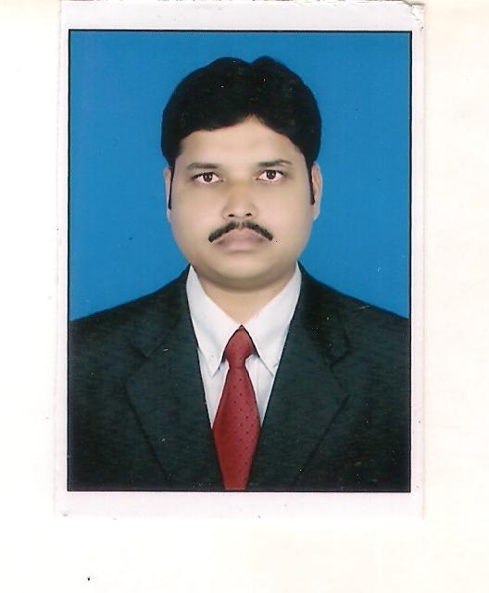
CURRICULUM VITAE

AMIT KUMAR

Email: kumar.amit719@gmail.com
Mobile - +91-8002036043

OBJECTIVE: To find a position while working with an organization that can utilize my range of skills and enhance my carrier goals.

EDUCATION DETAILS
  Academics | Year | Institution | Board/University | Percentage
  M.A | 2010 | PURNEA COLLEGE  PURNEA | B.N.M.U  MADHEPURA | 61.810
  B.A(HISTORY) | 2006 | PURNEA COLLEGE, PURNEA | IGNOU,DELHI | 59.410
  I.Sc. | 2001 | PURNEA COLLEGE, PURNEA | B.I.E.C, PATNA | 80.330
  MATRIC | 1999 | ZILA SCHOOL  PURNEA | B.S.E.B,PATNA | 55.710

TECHNICAL  QUALIFICATION
  Academics | Year | Institution | Board/University | Percentage
  PGDMM | 2011 | PURNEA COLLEGE  PURNEA | NOU,PATNA | 60.330
  BLIS | 2009 | SEEMANCHAL PURNEA | VINAYAKA  MISSION  UNIVERSITY | 71.250
  DCA | 2005 | AMBEDKAR COMPLEX,PURNEA | IICE,PATNA | 70.000
  TYPING | 2005 | T.R.COMMERCIAL  INSTITUTE,  PURNEA | T.R.COMMERCIAL  INSTITUTE,  PURNEA | Eng(40w/m)  Hnd(35w/m)

PERSONAL INFORMATION

Father’s name | Ramawtar Yadav
Date of Birth | 10 jan 1983
Email id | kumar.amit719@gmail.com
Sex | Male
Marital Status | Single
Nationality | Indian
Address of Correspondence | S/O-RAMAWTAR YADAV  BAGHMARA,BELARIKABGANJ, PURNIA,(BIHAR),PIN NO.-854301
Permanent Address | S/O-RAMAWTAR YADAV  BAGHMARA,BELARIKABGANJ, PURNIA,(BIHAR),PIN NO.-854301
Languages Known | Hindi – Read, Write & Speak English - Read, Write & Speak

HOBBY: - Event Management

DECLARATION:
I hereby declare that all the information given above about me is true to the best of my knowledge.

Place: Purnea
AMIT KUMAR
Date: 31/12/2011

